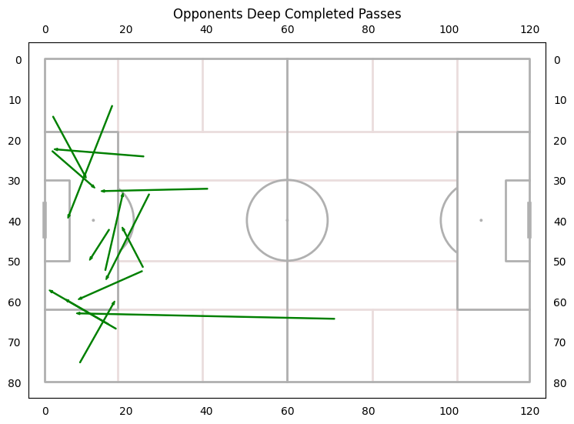

Opponents deep completed passes: 14 in the whole game. 9 in the first half with 5 being on the right side.

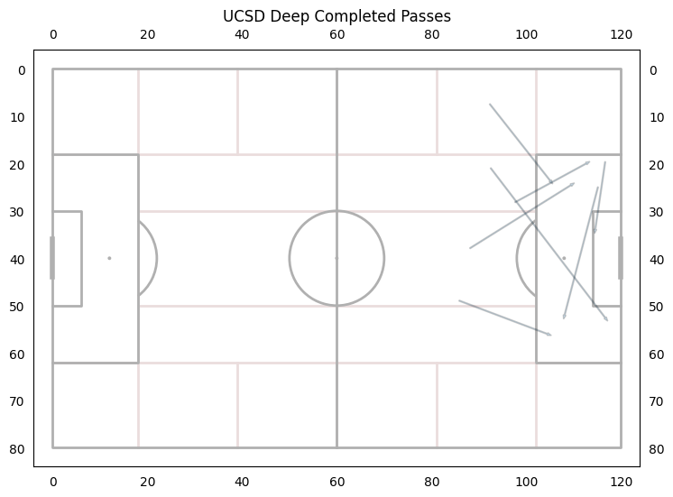

UCSD deep completed passes: 7 deep completed passes in the game.

Throw Ins- We had 16 throw ins and were only accurate 75% of the time

SDSU had a throw in percentage of 86%

**In The Graphs Below UCSD is Attacking to the Right**

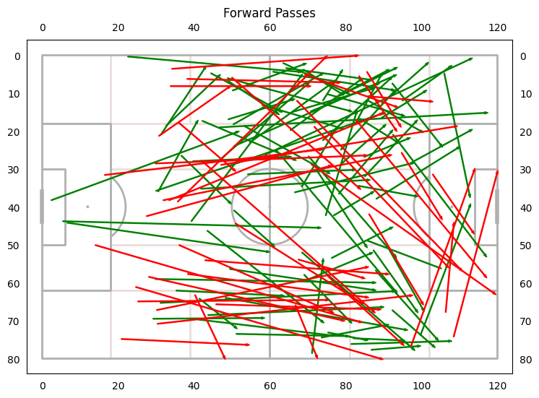

135 attempted forward passes - 134 avg last year

67% accurate - Goal is 72%

Average length of successful: 26.96

Average length of unsuccessful: 41.89

1st Half 64.6% accurate

Average length of 33.66

2nd Half 70% accurate

Average length of 30.1

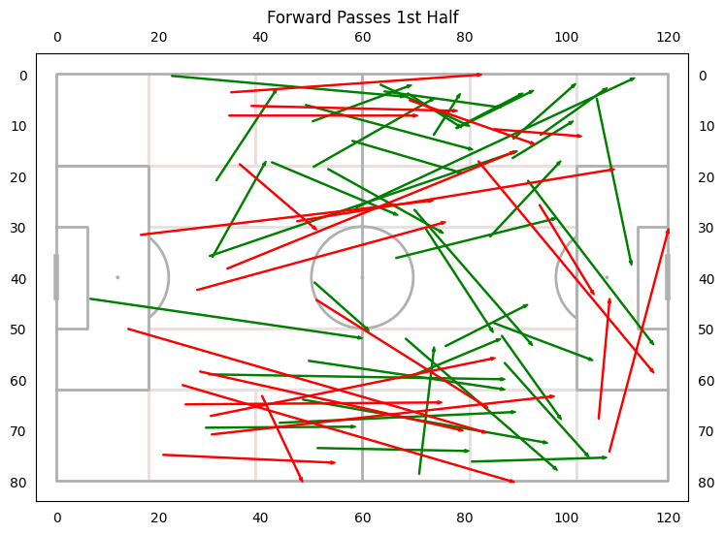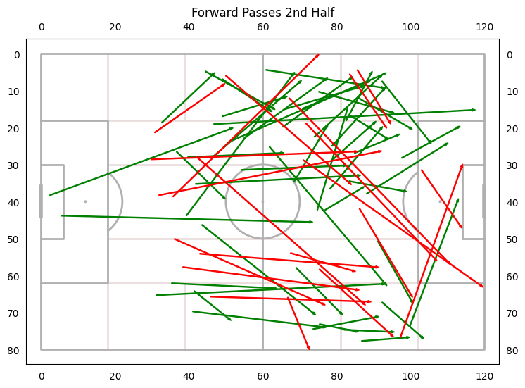



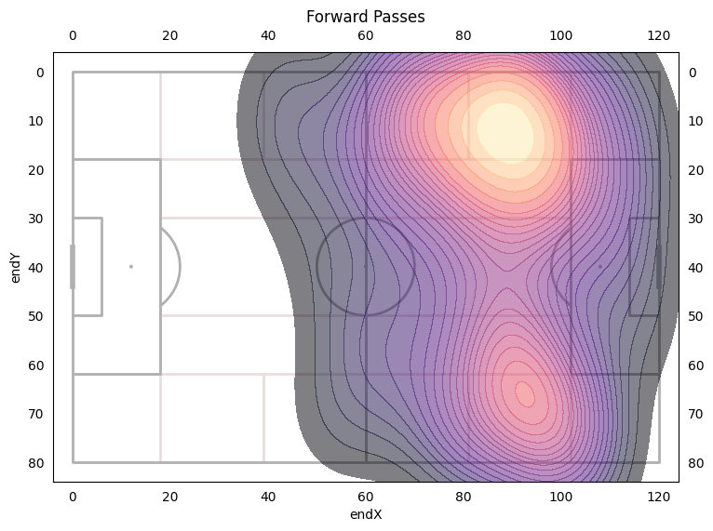

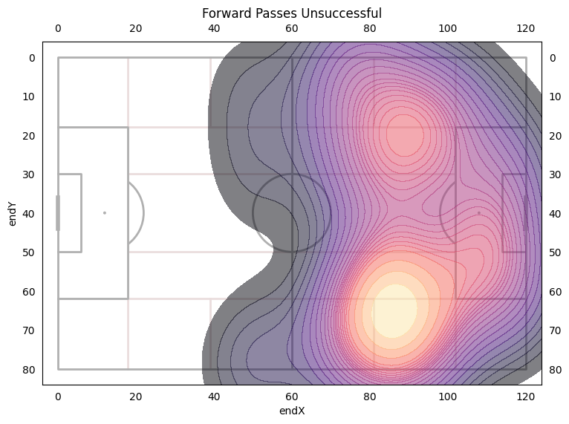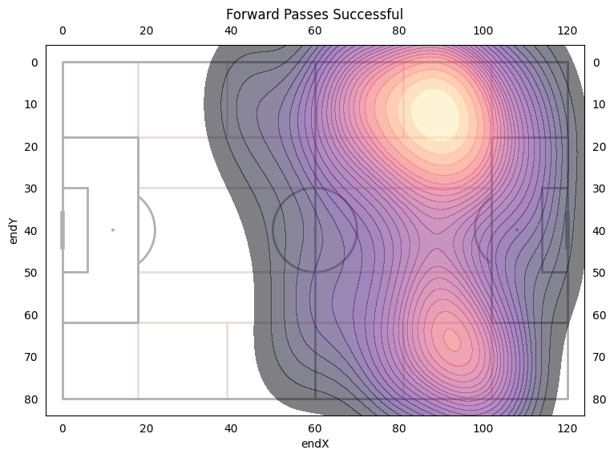



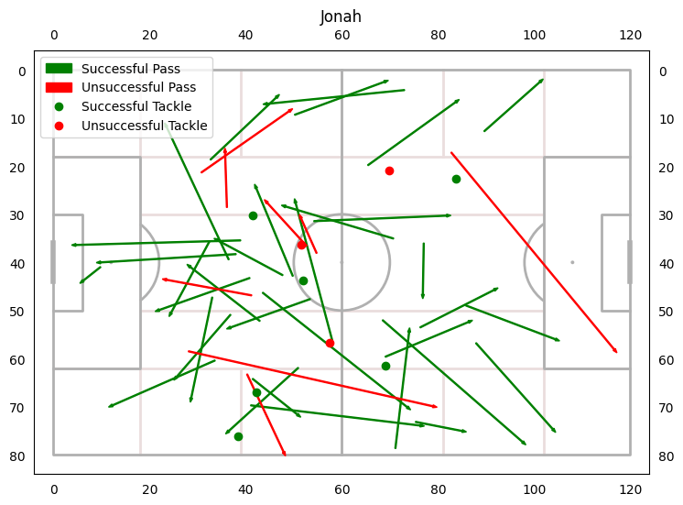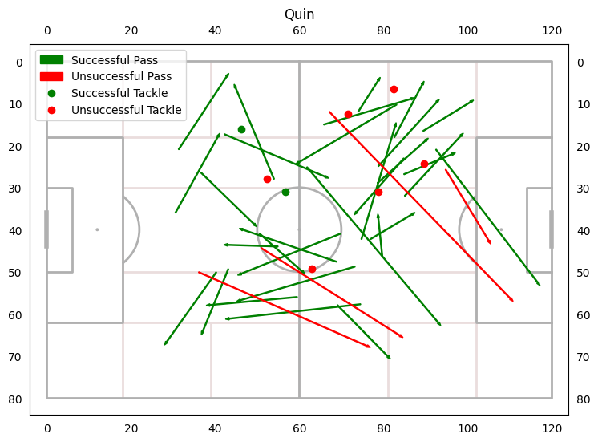

Jonah had 41 Passes and Accuracy of 81%

Passed Backwards 53% of the time

Won 67% of his duels

Quin had 34 Passes and Accuracy of 88%

Passed Backwards 35% of the time

Won 25% of his duels

Val only kept possession of the ball 55% of the time